**Power BI Assignment 2**

1. **Explain the advantages of Natural Queries in Power BI with an example?**

**Ans.** – A **Natural Language Query** is input that consists solely of terms or phrases spoken normally or entered as they might be spoken, without any non-language characters, such as the plus symbol or the asterisk, and without any special format or alteration of syntax. The **Advantages/Benefits of Natural Queries** are as below –

1. Guided Natural Language Query is a unique self-service BI experience. It provides immediate assistance on the question you want to ask, with no guesswork or technical knowledge required to get started with using the tool.

Example - After selecting a dataset, you’re presented with a search box you can type in, but it’s not blank. Guided NLQ provides a list of options for possible questions, and then guides you through each step in formulating the query. You can choose your own path through the question by typing what you want to ask, using your mouse to choose an option, or both.

These add-on elements can help build your query, and lead toward a more relevant result than traditional free text search.

Once your query is built, Guided NLQ presents the ideal level of data you need to uncover the answer, delivered as a [best practice data visualization](https://www.yellowfinbi.com/analytics-best-practice) (chart), which can also be viewed in tabular form.

1. Every question is understood by Guided Natural Language Query.
2. NLQ makes it simple to ask complex questions. The questions you can ask search-based Natural Language Query tools are often too basic because the vendor has spent all their effort in fixing the language problem, and their approach doesn’t support question complexity in the best way.

Example –

* Tabular and cross-tab reports
* Automatic highlighting of items on charts, such as outliers, values, trends
* Set analysis comparison, ranking, calculations
* Sub Queries, including minus, intersect

Whether you have a complex question, such as finding accounts that had more sales this month vs. last month for specific product SKUs, or a basic question, such as a comparison of annual business performance from one year to the next.

1. **Explain Web Front End (WFE) cluster from Power BI Service Architecture?**

**Ans.** – The **Web Front End (WFE)** cluster- manages the initial connection and authentication to the Power BI service.

**Power BI Architecture –**

The Power BI service architecture enables the user to create and access various reports and dashboards from the client platforms. The user needs to request or interact with the Power BI service to get data on the Power BI.

The Power BI implementation includes two major clusters. Such as a **Web Front End (WFE)** cluster and a Back-End cluster.

The **WFE** cluster uses Azure AD to authenticate clients, and provide tokens for subsequent client connections to the Power BI service. Power BI uses the **Azure Traffic Manager** (Traffic Manager) to direct user traffic to the nearest datacentre. Traffic Manager directs requests using the DNS record of the client attempting to connect, authenticate, and to download static content and files. Power BI uses the **Azure Content Delivery Network** (CDN) to efficiently distribute the necessary static content and files to users based on geographical locale.

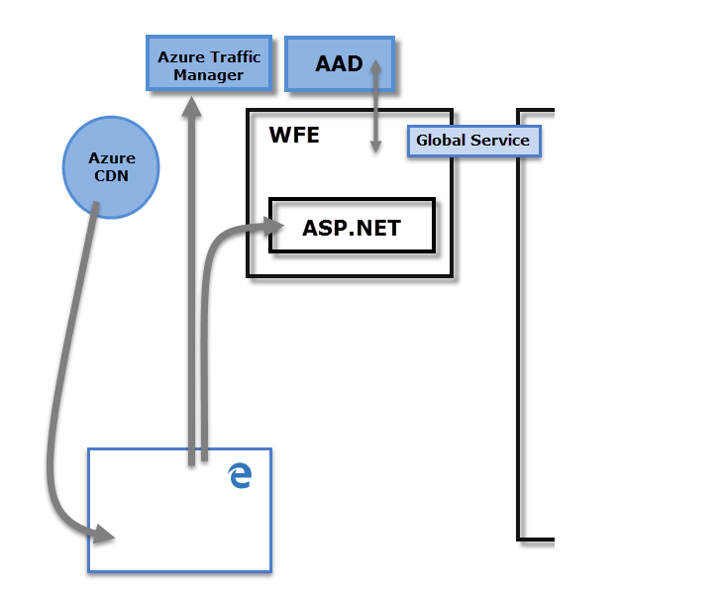

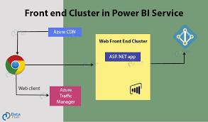

1. **Explain Back End cluster from Power BI Service Architecture?**

**Ans.** – Back End Cluster: **It manages the datasets, reports, storage, visualizations, data refreshing, data connections, and other services in the Power BI**. At the back end cluster, the web client has only two direct points to interact with the data, i.e., Gateway Role and Azure API Management.

The **Back-End** cluster determines how authenticated clients interact with the Power BI service. The **Back-End** cluster manages visualizations, user dashboards, datasets, reports, data storage, data connections, data refresh, and other aspects of interacting with the Power BI service. The **Gateway Role** acts as a gateway between user requests and the Power BI service. Users don't interact directly with any roles other than the **Gateway Role**. **Azure API Management** eventually handles the **Gateway Role**.

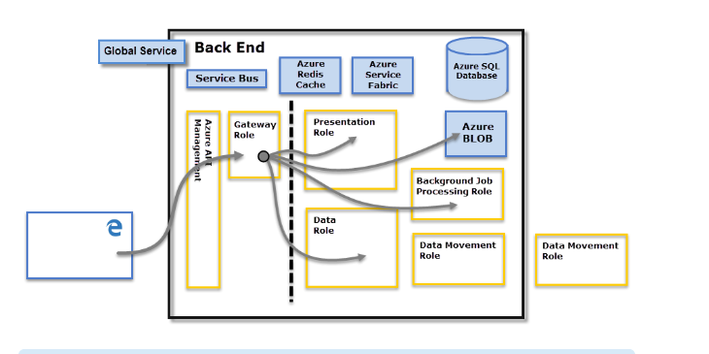

1. **What ASP.NET component does in Power BI Service Architecture?**

**Ans.** – A WFE cluster consists of an ASP.NET website running in the [Azure App Service Environment](https://learn.microsoft.com/en-us/azure/app-service/environment/intro). When users attempt to connect to the Power BI service, the client's DNS service may communicate with the Azure Traffic Manager to find the most appropriate (usually nearest) datacentre with a Power BI deployment. For more information about this process, see [Performance traffic-routing method for Azure Traffic Manager](https://learn.microsoft.com/en-us/azure/traffic-manager/traffic-manager-routing-methods#performance-traffic-routing-method).

Static resources such as *.js, *.css, and image files are mostly stored on Azure Content Delivery Network (CDN) and retrieved directly by the browser. Note that Sovereign Government cluster deployments are an exception to this rule, and for compliance reasons will omit the CDN and instead use a WFE cluster from a compliant region for hosting static content.

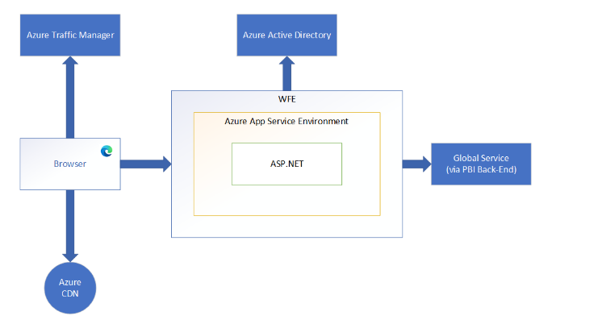

1. **Compare Microsoft Excel and Power BI Desktop on the following features:**

**Ans. –**

1. **Data import –**

**Excel** has limitations in the amount of data it can work with. In contrast, Power BI can handle much larger amounts of data.

**Power BI** can connect to a large number of data sources, while Excel's connectivity capacity is limited. Also, unlike Excel, Power BI can be easily used from mobile devices.

1. **Data transformation –**

Under this **Power BI** Transform Data session, all the different data sources are listed with the default data source's file name, i.e., when an SQL table is loaded, the table's name gets listed in this session, and if you load an Excel file, then it's file name shows up.

And in **Excel** - modifying it in some way to meet your data analysis requirements. For example, you can remove a column, change a data type, or filter rows. Each of these operations is a data transformation.

1. **Modelling –**

In **Power BI** Ideal for building complex data models easily.  Power BI dashboards are more visually appealing, interactive and customizable than those in Excel. Power BI is a more powerful tool than Excel in terms of comparison between tables, reports or data files.

And In **Excel** Ability to work on simple and structured data models.

1. **Reporting –**

In **Excel** Simpler and less attractive reports we can create and visualize.

In **Power BI** reports are more beautiful, personalized, attractive and interactive reports.

1. **Server Deployment –**

In **Power BI** you can connect and extract data from virtually any platform, software & application.

In **Excel** we have limited connectivity with other applications and systems.

1. **Convert Models –**

In **Power BI** we can use DAX Language to convert the data model. With the help of different DAX command we can easily achieve what we want and what we need to show to business in dashboard by using different visualization.

In **Excel** We can use MDX Language but mostly we used to organize data, perform calculations, Pivots and basic data view representation to business.

1. **Cost –**

**Excel** has Payment tool but have less cost as compare to power BI.

**Power BI** has Free version as well as payment version. But if you want to use all visuals which is available in power BI then you have to go for Payment Version.

1. **List 20 data sources supported by Power Bi desktop.**

**Ans.** – With Power BI Desktop, you can connect to data from many different sources.The **Get Data** dialog box organizes data types in the following categories:

* All
* File
* Database
* Power Platform
* Azure
* Online Services
* Other

### In File data sources –

1. Excel Workbook
2. Text/CSV
3. XML
4. JSON
5. Folder
6. PDF
7. Parquet
8. SharePoint folder

### In Database data sources –

1. SQL Server database
2. Access database
3. MySQL database
4. PostgreSQL database
5. SAP HANA database
6. SAP Business Warehouse Application Server
7. SAP Business Warehouse Message Server
8. Amazon Redshift
9. Snowflake
10. Essbase
11. BI Connector

### In Power Platform data sources –

1. Power BI datasets
2. Datamarts (preview)
3. Power BI dataflows (Legacy)
4. Common Data Service (Legacy)
5. Dataverse
6. Dataflows

### In Azure data sources –

1. Azure SQL Database
2. Azure Synapse Analytics SQL
3. Azure Analysis Services database
4. Azure Database for PostgreSQL
5. Azure Blob Storage
6. Azure Table Storage
7. Azure Cosmos DB

***.***